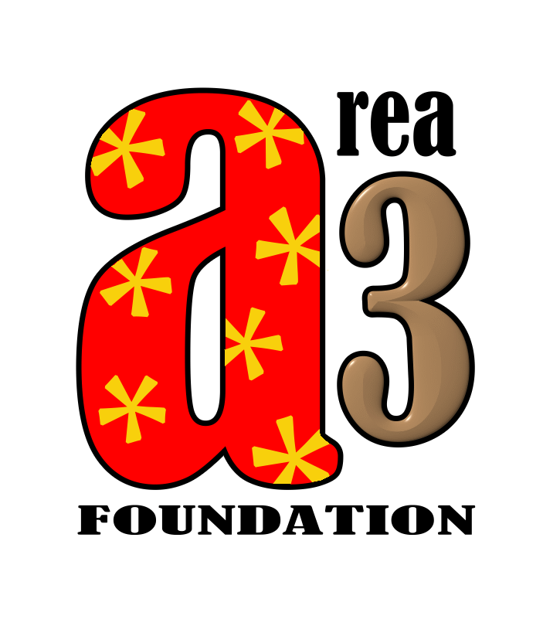
Rescue Referral

The Area 3 Foundation has a limited amount of emergency funds to help those in need.

Eligibility
- Minimum of two years of full-time service at the Walt Disney World Resort in the character department at any of the Orlando resorts or two years of casual regular employment. Or the child of an employee that meets the employment criteria.
- Completed application by self or nominee.
- Preference is given to a current or former cast member of the Magic Kingdom Character department.

Fund Availability
- Gift cards for groceries, gas or household supplies
- Airline tickets for bereavement or caretaking responsibilities of immediate family
- Direct payment assistance of hospital and medical bills for care of self or immediate family
- Other financial assistance based on application and in compliance with IRS requirements for non-profit foundations.

Application for Assistance

Who is this request for? Click here to enter text.

Request completed by: Click here to enter text.

What is the contact’s information

Click here to enter text.
Street Address (or P.O. Box)

Click here to enter text. Click here to enter text.
City State Zip Code

Click here to enter text.
Phone Number with Area Code Email Address

Please write a brief description of the reason this person should be awarded emergency funds from the Area 3 Foundation (may omit detailed specifics to avoid violating nominees privacy).

Click here to enter text.

What other resources are there? (i.e. one partner has income, unemployment, child support)
Click here to enter text.

What assistance are you requesting? (groceries, gas, travel, medical expenditure, other)
Click here to enter text.

This must be documented either over the phone by the person taking the call or in an email.

Please submit the application to: rescue@area3foundation.org

For office use only:

Board Approved Date: Click here to enter text.

Approval Method: Click here to enter text.

Action Taken: Click here to enter text.

“Other” is at the discretion of IRS rules of providing assistance.

